Lab Worksheet

Hypotheses

Activity 1. Activity 2.

Photograph each activity following these instructions: When taking lab photos, you need to include in each image a strip of paper with your name and the date clearly written on it.
Step 12 will require you to make a line graph.
Should you desire further guidance on how to construct a graph, it is recommended that you review the Introduction to Graphing lab manual. (You are not
Expected to complete any of the activities in this
Manual.)

Observations/Data Tables

Data Table 1. Sea Ice

Time (min) | Estimated Depth (m) | Measured Depth (cm) | Observations
0 | 0.1 | 10 | The water level remained constant as expected.
10 | 0.15 | 14 | The water level increased to almost the expected level.
20 | 0.2 | 18 | The water depth rose to near the expected level.
30 | 0.25 | 23 | The rate of water melting seems to be taking a constant rate of 5cm per every ten minutes.
40 | 0.3 | 28 | The water level rose to 28cm, a value close to the estimated one of 30cm.
50 | 0.35 | 32 | The water depth rose to near the expected level.
melted | 0.4 | 38 | The water level finally rose to 38cm, a value close to the estimated one of 40cm.

Continued on next page

Data Table 2. Glacier Ice

Time (min) | Estimated Depth (m) | Measured Depth (cm) | Observations
0 | 0.1 | 10 | The water level remained constant as expected.
30 | 0.2 | 18 | The water level increased to almost the expected level.
60 | 0.3 | 28 | The water depth rose to near the expected level
90 | 0.4 | 37 | The rate of water melting seems to be taking a constant rate of 11cm per every ten minutes.
120 | 0.5 | 48 | The water depth rose to near the expected level
150 | 0.6 | 57 | The water level rose to 57cm, a value close to the estimated one of 60cm.
melted | 0.7 | 68 | The water level finally rose to 68cm, a value close to the estimated one of 70cm.

Calculations (paste your line graph from Activity 2, step 12 here)

Photographs
Activity 1.

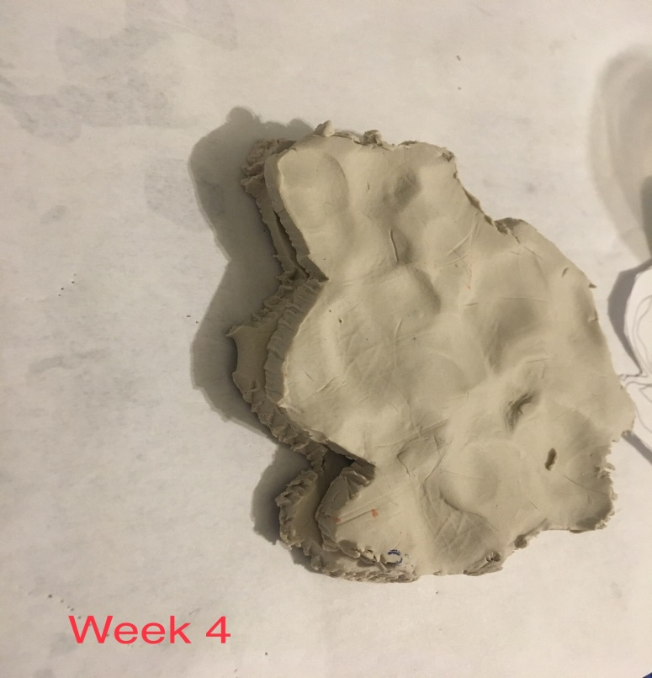

Activity 2.
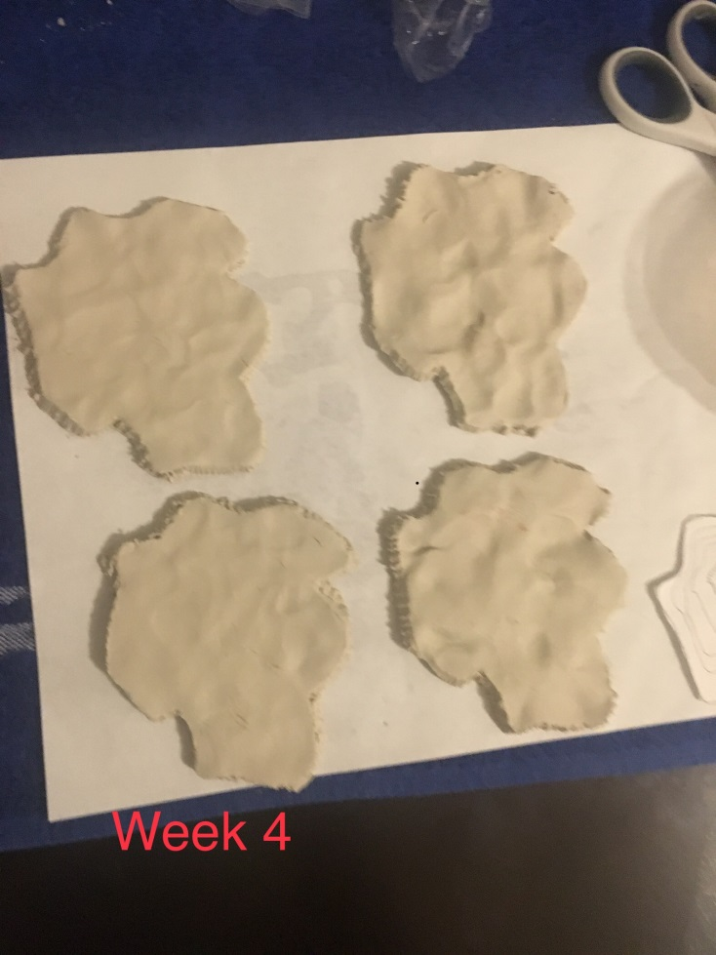
Lab Questions
Please answer the following entirely in your own words and in complete sentences:
Introduction
- Background—What is important to know about the topic of this lab?
A lot of controversy has been surrounding the idea of climate change and global warming. Among the effects of climate change are rise in sea levels due to glacier ice melting. When the concentration of gases in the atmosphere is non-uniform, the atmosphere forms concentric layers, with water and carbon dioxide layer being nearer to the earth’s surface. When solar radiations hit the earth and oceans, water and air rise and condense and condense in the atmosphere. Due to the effect of greenhouse gases, the condensed air does not melt completely but fall on hill tops and mountains as ice. Due to global warming, the ice the melts and flows into oceans causing a rise in the sea level. The cycle repeats itself.

- Outcomes—What was the main purpose of this lab?
The main aim of this lab was to demonstrate the consequences resulting from anthropogenic carbon emissions, climate change, and the rise in sea level. This will help the students understand how melting ice and glacier ice result in rise of the sea level and the accompanying effects of the potential consequence of climate change.

- Hypotheses—What were your hypotheses for Activity 1? What were your hypotheses for Activity 2? Identify each hypothesis clearly, and explain your reasoning.
Activity 1: Taking lab photos, you need to include in each image a strip of paper with your name and the date clearly written on it. Photos of the experiment mounts will help in easy identification of the activity being done and the results of the activity.
Activity 2: make a line graph. Should you desire further guidance on how to construct a graph, it is recommended that you review the Introduction to Graphing lab manual. A graph is an easy way of making analysis, comparison and presentation of the obtained data.

Materials and Methods
- Using your own words, briefly describe what materials and methods you used in each of the activities. Your answer should be sufficiently detailed so that someone reading it would be able to replicate what you did. Explain any measurements you made.

Materials needed: plastic container with a lid, two pieces of modeling clay, two medicine cups, food coloring, beaker, ruler, plastic cup and a sharpie marker.
Methods: making ice using a mixture of tap water, food coloring and dipping it into a freezer.
Sea ice and sea level rise: place a teaspoon of salt into tap water to make it salty. Add ice and take water depth readings after ten minutes as the ice melts and record the observations in a table.

Discussion
- Based upon the results of each activity, explain whether you accepted or rejected your hypotheses and why.
The results of activity one was according to the hypothesis. I accept that ice is formed from condensed water molecules. When moisture in air condenses, it forms ice at high altitudes.
The results of activity two are also true. Salty conditions such as sea water melt sea ice. Once sea ice melts, the sea level increases as observed by the increase of the depth of the salty water.

- What important information have you learned from this lab? Use at least one outside source (scholarly for full credit) to answer this question. Cite the source using APA format.
Answers should be 5–7 sentences in length.
From this lab, I have learned that glacier and melted ice are a major contribution in the rise of sea level. I have also learned about the effect of greenhouse gases on the rise of sea level. Greenhouse gases cause global warming hence glacier ice melts more quickly causing a rise in the sea level. This entirely results in un-predictable consequences of shift in weather patterns and corresponding changes in the natural biodiversity. Loss in mountain glaciers also causes changes in the availability of fresh water hence affecting human life and that of animals.

- What challenges did you encounter when doing this lab? Name at least one.
The challenges faced while doing this lab is the unavailability of the appropriate equipment to show the entire flow of the system. That is, from the sea water, to the atmosphere, to the mountain glacier and sea ice and back to the sea water.

- How might a scientist create a more realistic physical model to show the effects of global climate change on sea level rise? What factors might be changed?
A scientist can create a more realistic model to perform this experiment. This can be achieved by having a basin of water which represents the sea water, pump into a freezer which represents the cool upper atmosphere, then to a table which is a mountain glacier and some back to the basin in ice form which will represent sea ice.

Literature Cited
9. List the references you used to answer these questions. (Use APA format, and alphabetize by the last
Name.)
Fankhauser, S. (2013). Valuing climate change: the economics of the greenhouse. Routledge.
Stocker, T. F., Qin, D., Plattner, G. K., Tignor, M., Allen, S. K., Boschung, J., ... & Midgley, P. M. (2013). Climate change 2013: The physical science basis.
Gillett, N. P., Fyfe, J. C., & Parker, D. E. (2013). Attribution of observed sea level pressure trends to greenhouse gas, aerosol, and ozone changes. Geophysical Research Letters, 40(10), 2302-2306.
Now copy and paste your answers into the Lab Report provided. Include the data tables and photographs. You may wish to make minor edits to enhance the flow of your resulting lab report.

